**Job Readiness Phase III**

You have been fine tuning your answers. Now it’s time to start submitting for positions. Once you start submitting, you will need to log your job submissions and interviews on the following page.

<http://app.colaberry.com/app/ipbc/ipbc/3151/jobsubmissions>

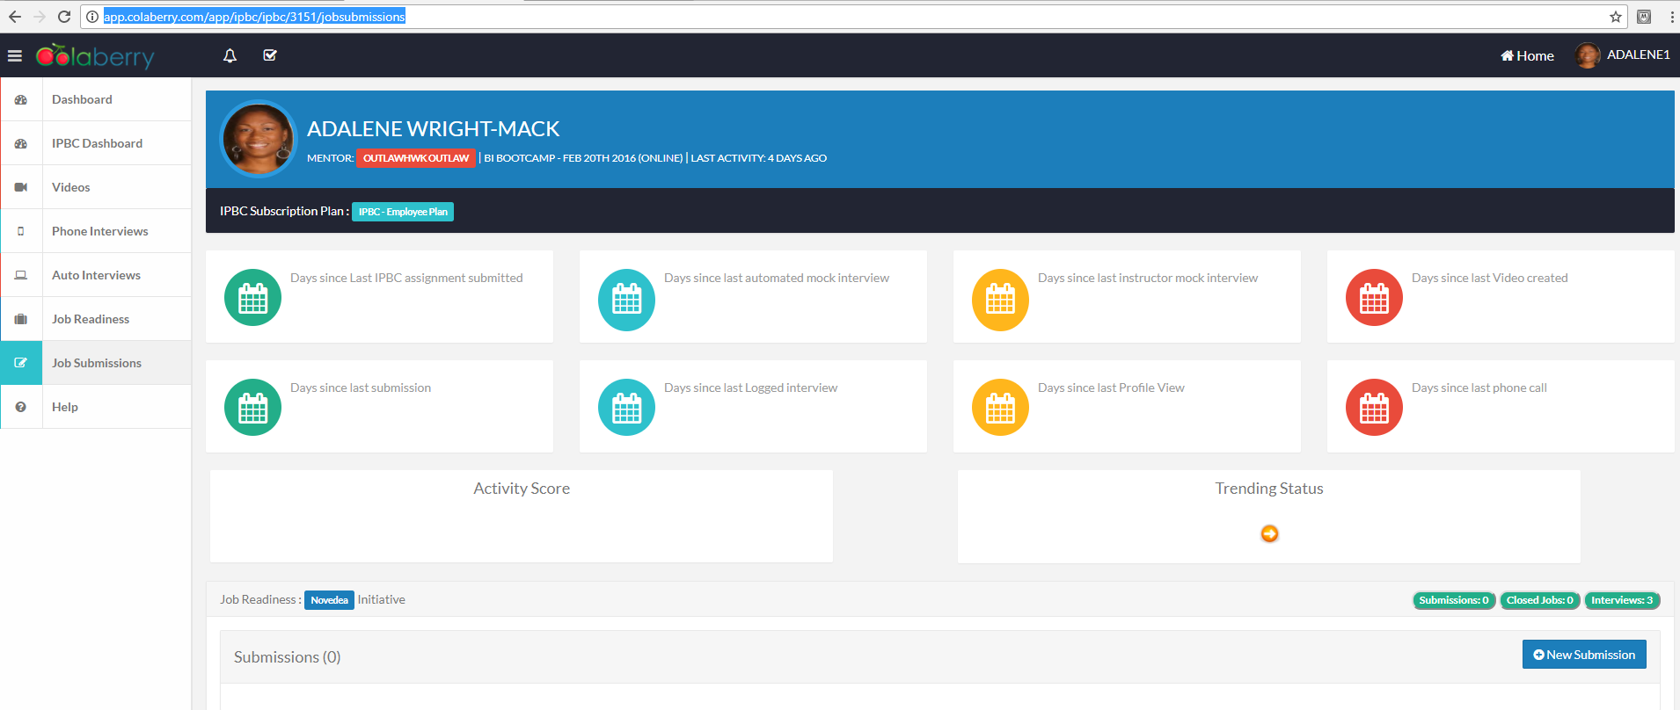

From this point on, you will NOT be charged a monthly fee unless your Activity Score is below 50% at the end of the month. Watch the following video to understand how the Activity Score is calculated.

<https://vimeo.com/220740599>

pw: Colaberry99

***Very Important: When you get a verbal offer from a company, let Ali know asap. I will then prep you for the background check and reference process. The sooner I know, the less problems that will occur.***

Even though you can now submit for positions, you want to make sure you are still going through the curriculum. Phase III focuses on White Boarding.

Please complete the following…

|  |  |  |  |
| --- | --- | --- | --- |
| **Path** | **Course** | **Section** | **Event** |
| SQL/BI | Interview Prep – Categorized | Interview Preparation | The Best job Interview Preparation Video |
| SQL/BI | Interview Prep – Categorized | Interview Preparation | Body Language That Gets the Job |
| SQL/BI | Interview Prep – Categorized | Interview Preparation | Selling Yourself in an Interview |
| SQL/BI | Interview Prep – Categorized | Interview Preparation | 7 Seconds to Sell Yourself |
| SQL/BI | Interview Prep – Categorized | Interview Preparation | 8 Interview Tips – Body Language |
| SQL/BI | Interview Prep – Categorized | Interview Preparation | Good Interview Answer to “Tell me about yourself” YouTube Top Pick |
| SQL/BI | Interview Prep – Categorized | Interview Preparation | Ram and Nate: Speaking Clearly |
| SQL/BI | Interview Prep – Categorized | Interview Preparation | Ram and Nate: Channeling energy and building trust |
| SQL/BI | Interview Prep – Categorized | Interview Preparation | Ram and Nate: Good Asset |
| SQL/BI | Interview Prep – Categorized | Interview Preparation | Ram and Nate: Question |
| SQL/BI | Interview Prep – Categorized | Interview Preparation | Ram and Nate: Closing the Interview |

**White Boarding:** In this field, the better you are able to teach and explain things, the higher your value. If you haven’t already, go to Walmart of any other store and purchase a small white board for this assignment. The next set of videos you will create are dedicated to White Boarding. You could possibly be asked to White Board a question in the interview. Being able to draw something complicated on the board and make it look easy is a skill all employers are looking for. You will have a chance to perfect this craft in this section.

White Boarding Exercise: Take your WhiteBoard, create, memorize and right out examples of the following… (don’t use emp and dept table – instead chose examples such as Orders and Customers table or Products and Sales table.

1. Example of Select statement with WHERE CLAUSE / GROUP BY / HAVING CLAUSE
2. Example of INNER JOIN / LEFT OUTER JOIN / RIGHT OUTER JOIN
3. Example of Stored Procedure
4. Example of UDF
5. Example of CTE

You should have examples syntax memorized. Once you have completed the above assignment, create the videos for the following. The above example applies to the 1st question below.

**Video(s) to Submit:**

**SQL BI Interview Questions**: White Boarding – Basic Syntax Questions

**SQL BI Interview Questions**: White Boarding – Explain the ETL Life Cycle

**SQL BI Interview Questions**: White Boarding – Create a query to remove duplicates

**SQL BI Interview Questions**: White Boarding – Explain Cascading Parameters and how to set them up

**SQL BI Interview Questions**: Give an example of a complex Stored Procedure

**SQL BI Interview Questions**: Give an example of a complex UDF

**What to Submit:**

1. **Mandatory Videos:** Copy and paste the link to your video(s) as part of your homework.
2. **Comments**: Watch, Comment & take screenshots of your comments from 3 other videos on the same topic (per question). Comments must be 20+ characters. Leave comments based on presentation, delivery and/or technical details. Your critiques will help you be more conscious of your own videos. (3 comment screenshots per Video Question)
3. **40 Videos** - Screenshot of Video Completion Dashboard showing 40+ Videos completed
4. **18 Mock Interviews:** Screenshot of Auto and Instructor Interview Dashboard showing 18+ Interviews completed